**Wellbeing Farm**

**A Pragmatic Approach to Transition and Permaculture Education**

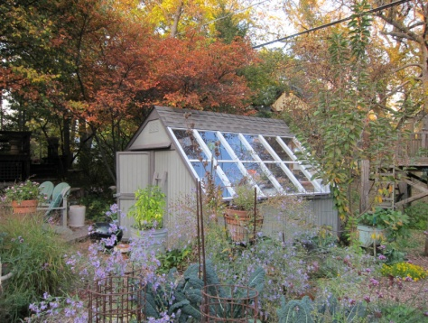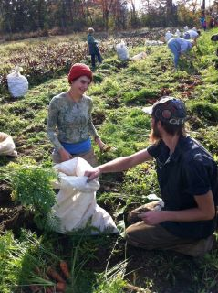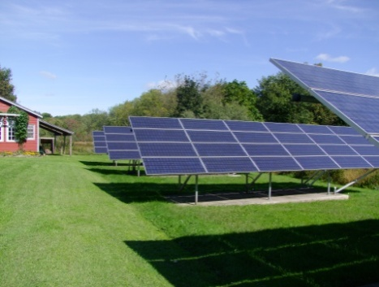

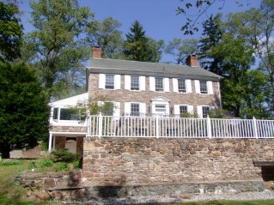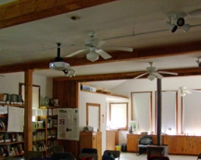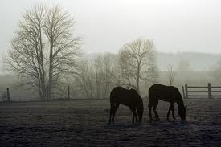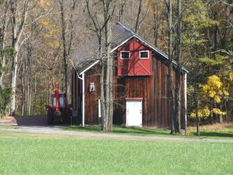

**A Proposal for a Center for Permaculture, the Crafts of Transition, and Cruelty Free Animal Husbandry as the Educational Component of the Master Plan for the Neu Family Farm**

*"Every community in the United States will have engaged its collective creativity to unleash an extraordinary and historic transition to a future beyond fossil fuels; a future that is more vibrant, abundant and resilient; one that is ultimately preferable to the present"*

The work of Wellbeing[1] Farm is to give a physical presence to moving beyond ‘environmental’, ’sustainable’, ‘eco’ this or that. This is about transition to where we want to get to, how do we do it and what might it look like – and giving people the tools to create more sustainable ways of living in their own homes and communities. It is also about how to design this transition in such a way that people will embrace it as a collective adventure, as a common journey, and as something positive. How can we design fossil fuel descent pathways which make people feel alive, positive and included in this process of societal transformation?

Housed at the Neu Family Farm Wellbeing Farm will provide complementary localized educational opportunities and creative, implementable, real world solutions to the environmental, economic, and social crises we are likely to face in the near and mid-term future.

The Wellbeing Farm educational component will fulfill one of the goals for the Permaculture plan for the Neu Family Farm. While we (re)build appropriate buildings at the Farm, we can consider how they could be used to address the needs of adult practitioners and students that would visit or be in residence at the farm.

**Wellbeing Farm will house:**

* Permaculture demonstration projects,
* Alternative energy and water conservation pilot projects
* And an educational facility built to a high energy efficiency standard while providing a beautiful, peaceful, productive space where students, scholars and practitioners can meet perhaps live, and study.

**Wellbeing farm will be a center:**

* for Permaculture,
* the crafts of Transition
* exploring cruelty free animal husbandry

**Wellbeing Farm will be:**

* A physical place where demonstrations of the efficacy of producing local food and power can take place
* Also a place that can provide opportunities for practitioners to have the time and space to develop specific implementable ideas for a world in transition from resource extraction and growth to a steady state sustainable one

**Wellbeing Farm will be:**

* One tool that will enable people to work locally to transition our towns, cities, counties and states away from a fossil fuel-based economy to a “restorative economy,” an economy dedicated to core values of human and environmental health and safety, cultural and biological diversity, care for commonly held resources, and cooperative nonviolence. A restorative economy is human-scaled. It embraces alternative locally based energy, is less extractive and less violent.

**Permaculture**

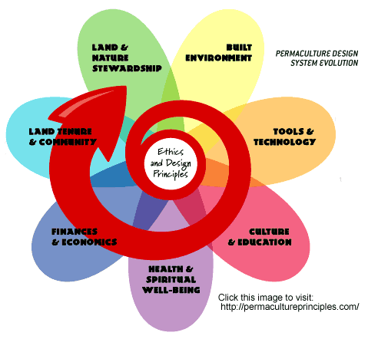

The word "permaculture" was coined in 1978 by Bill Mollison, an Australian ecologist, and one of his students, David Holmgren. It is a contraction of "permanent agriculture" or "permanent culture.""

Permaculture is about designing ecological human habitats and food production systems. It is a land use and community building movement which strives for the harmonious integration of human dwellings, microclimate, annual and perennial plants, animals, soils, and water into stable, productive communities. The focus is not on these elements themselves, but rather on the relationships created among them by the way we place them in the landscape. This synergy is further enhanced by mimicking patterns found in nature.

A central theme in permaculture is the design of ecological landscapes that produce food. Emphasis is placed on multi-use plants, cultural practices such as sheet mulching and trellising, and the integration of animals to recycle nutrients and graze weeds.

Permaculture is a branch of [ecological design](http://en.wikipedia.org/wiki/Ecological_design) and [ecological engineering](http://en.wikipedia.org/wiki/Ecological_engineering) which develops [sustainable](http://en.wikipedia.org/wiki/Sustainable) human settlements and self-maintained [agricultural](http://en.wikipedia.org/wiki/Agricultural) systems modeled from natural [ecosystems](http://en.wikipedia.org/wiki/Ecosystems). The core tenets of Permaculture are:

• *Take Care of the Earth*: Provision for all life systems to continue and multiply. This is the first principle, because without a healthy earth, humans cannot flourish.

• *Take Care of the People:* Provision for people to access those resources necessary for their existence.

• *Share the Surplus:* Healthy natural systems use outputs from each element to nourish others. We humans can do the same. By governing our own needs, we can set resources aside to further the above principles.

Permaculture draws from several disciplines including [organic farming](http://en.wikipedia.org/wiki/Organic_farming), [agroforestry](http://en.wikipedia.org/wiki/Agroforestry), [integrated farming](http://en.wikipedia.org/wiki/Integrated_farming), [sustainable development](http://en.wikipedia.org/wiki/Sustainable_development), and [applied ecology](http://en.wikipedia.org/wiki/Applied_ecology).

"*The primary agenda of the movement has been to assist people to become more self-reliant through the design and development of productive and sustainable gardens and farms. The design principles which are the conceptual foundation of Permaculture were derived from the science of*[*systems ecology*](http://en.wikipedia.org/wiki/Systems_ecology)*and study of pre-industrial examples of*[*sustainable*](http://en.wikipedia.org/wiki/Sustainable)*land use.*"

Permaculture design emphasizes patterns of landscape, function, and species assemblies. It asks the question, “Where does this element go? How can it be placed for the maximum benefit of the system?" To answer this question, the central concept of Permaculture is maximizing useful connections between components and [synergy](http://en.wikipedia.org/wiki/Synergy) of the final design. The focus of Permaculture, therefore, is not on each separate element, but rather on the relationships created among elements by the way they are placed together; the whole becoming [greater than the sum of its parts](http://en.wikipedia.org/wiki/Emergence). Permaculture design therefore seeks to minimize waste, human labor, and energy input by building systems with maximal benefits between design elements to achieve a high level of [synergy](http://en.wikipedia.org/wiki/Synergy). Permaculture designs evolve over time by taking into account these relationships and elements and can become extremely complex systems that produce a high density of food and materials with minimal input.

Permaculture is an approach to designing human settlements and agricultural systems that is modeled on the relationships found in nature. It is based on the [ecology](http://en.wikipedia.org/wiki/Ecology) of how things interrelate rather than on the strictly biological concerns that form the foundation of [modern agriculture](http://en.wikipedia.org/wiki/Intensive_farming). Permaculture aims to create stable, productive systems that provide for human needs; it's a system of design where each element supports and feeds other elements, ultimately aiming at systems that are virtually [self-sustaining](http://en.wikipedia.org/wiki/Self-sustainability) and into which humans fit as an integral part.

However, permaculture entails much more than just food production. Energy-efficient buildings, waste water treatment, recycling, and land stewardship in general are other important components of permaculture. More recently, permaculture has expanded its purview to include economic and social structures that support the evolution and development of more permanent communities, such as co-housing projects and eco-villages. As such, permaculture design concepts are applicable to urban as well as rural settings, and are appropriate for single households as well as whole farms and villages.

**Transition**

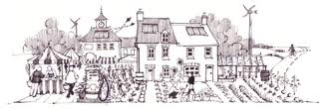

The Transition movement represents one of the most promising models available to us for engaging people and communities, to achieve the far-reaching actions required to mitigate the effects of peak oil, climate change and the economic crisis. Furthermore, Transition re-localization efforts are designed to result in a life that is more fulfilling, more socially connected and more equitable than the one we live today.

The Transition model is based on a loose set of real world principles and practices built up over time through experimentation and observation by Transition communities around the world as they drive forward to reduce carbon emissions and build community resilience. Underpinning the model is recognition of the following: [peak oil](http://transitionus.org/why-transition/peak-oil), [climate change](http://transitionus.org/why-transition/climate-change) and the [economic crisis](http://transitionus.org/why-transition/economic-crisis) require urgent action; a world with less oil is inevitable so adaptation now is essential; it is better to plan and be prepared, than be taken by surprise; industrial society has lost the resilience to cope with shocks to its systems so we must act together now to work our way down from the “peak”; using all of our skill, ingenuity and intelligence, our home-grown creativity and cooperation, we can unleash the collective genius within our communities, leading directly to a more abundant, connected and healthier future for all.

The Term Transition was first introduced by the [Global scenario group](http://en.wikipedia.org/wiki/Global_scenario_group) (GSG), an faculty international body of scientists convened in 1995 by the [Tellus Institute](http://en.wikipedia.org/wiki/Tellus_Institute" \o "Tellus Institute)[2] and [Stockholm Environment Institute](http://en.wikipedia.org/wiki/Stockholm_Environment_Institute)[3] to examine the requirements for a transition to a sustainable global society. The GSG set out to describe and analyze scenarios for the future of the earth as it entered a [Planetary Phase of Civilization](http://en.wikipedia.org/wiki/Planetary_Phase_of_Civilization). The GSG's [scenario analysis](http://en.wikipedia.org/wiki/Scenario_analysis) resulted in a series of reports and its findings were summarized for a non-technical audience in the essay [Great Transition: the Promise and Lure of the Times Ahead](http://www.gtinitiative.org/documents/Great_Transitions.pdf).[4]

In this essay, the [Global Scenario Group](http://en.wikipedia.org/wiki/Global_Scenario_Group) explains that [civilization](http://en.wikipedia.org/wiki/Civilization) is now in a moment of transition in which “all components of [culture](http://en.wikipedia.org/wiki/Culture) will change in the context of a holistic shift in the structure of society and its relation to nature…transforming values and knowledge, [demography](http://en.wikipedia.org/wiki/Demography) and social relations, economics and governance, and technology and the environment.”  Out of the turbulence of transition, very different forms of global society could emerge. The choices we make over this next critical decade could set the trajectory of global development for generations to come. The Great Transition essay contends that the realization of a Great Transition world depends in part on whether those living today contest the current roles of transnational corporations and state governments (i.e., through the emergence of an authentic [global citizens movement](http://en.wikipedia.org/wiki/Global_citizens_movement)).

The Transition concept emerged from work that [permaculture](http://en.wikipedia.org/wiki/Permaculture) designer [Rob Hopkins](http://en.wikipedia.org/w/index.php?title=Rob_Hopkins&action=edit&redlink=1) had done with the students of Kinsale Further Education College in writing an "Energy Descent Action Plan". This looked at across-the-board creative adaptations in the realms of energy production, health, education, economy and agriculture as a "road map" to a sustainable future for the town. Two of his students, Louise Rooney and Catherine Dunne, set about developing the Transition Towns concept and took the far-reaching step of presenting it to Kinsale Town Council, resulting in the historic decision by Councilors to adopt the plan and work towards energy independence.

The idea was adapted and expanded through 2005, 2006, and beyond in Hopkins' hometown of Totnes where he is now based. The initiative spread quickly, and as of July 2012, there are over [400 communities](http://www.transitionnetwork.org/initiatives?themes=All&community_type=All&status_value=official&country=All&field_title_search=) recognized as official Transition Towns in the [United Kingdom](http://en.wikipedia.org/wiki/United_Kingdom), [Ireland](http://en.wikipedia.org/wiki/Ireland), [Canada](http://en.wikipedia.org/wiki/Canada), [Australia](http://en.wikipedia.org/wiki/Australia), [New Zealand](http://en.wikipedia.org/wiki/New_Zealand), the [United States](http://en.wikipedia.org/wiki/United_States), [Italy](http://en.wikipedia.org/wiki/Italy) and [Chile](http://en.wikipedia.org/wiki/Chile). The term "Transition Towns" has morphed into "Transition Initiatives" to reflect the range and type of communities involved.

In the United States, Transition initiatives have sprung up in many communities. Transition US[5] is the national hub. Transition US is a resource and catalyst for building resilient communities across the United States that are able to withstand severe energy, climate or economic shocks while creating a better quality of life in the process. They are accomplishing this mission by inspiring, encouraging, supporting, networking and training individuals and their communities as they consider, adopt, adapt, and implement the Transition approach to community empowerment and change.

We live at a fascinating point in history. The convergence of challenges, most particularly global warming and peak oil, have brought us to a point where we are profoundly challenged to act. We are surrounded by “experts” telling us that this means the end, that we have gone too far, that it is inevitable that life as we know it will collapse catastrophically and very soon.Yet, at the same time, something very powerful is stirring and is taking root the world over. People are choosing life and are manifesting that in their lives and their communities. People are starting to see “peak everything” as the Great Opportunity, the chance to build the world they always dreamt of.

The scale of the challenge is huge, and the obstacles are plenty, but there is an emerging energy to succeed, a sense of exhilaration in talking and listening to each other once again, to visioning what we want and then rolling up our sleeves and starting to co-create it. This is not a denial of the scale of the challenges we face, rather a practical and instinctual response to it. In towns and cities all over the world people are asking each other “what can we do about this?”

**Cruelty Free Animal Husbandry**

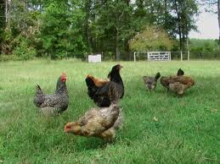  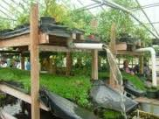

Another goal for The Neu Family Farm is for it to become a Sanctuary for old, mistreated, and/or abandoned domestic and farm animals. The Farm will potentially provide a location for the rehabilitation and ultimate adoption, of NY City’s carriage horses. Permaculture, biodynamic, and organic farming are dependent on the nutrients produced by the manure of large and small farm animals to fertilize the soil and complete the cycle of production. A farm animal sanctuary will be unique in that it serves the purpose of fertilization from composted manure while letting the animals live out their lives in a cruelty-free environment.

There is an option, if agreed to by the principals, to raise tilapia fish (in an aquaponics facility),[6] goats, and chickens for milk, meat, and eggs that would follow guidelines established for cruelty free animal husbandry. According to the NRDC some of the key practices that indicate a humane farm are:

* Chickens are un-caged, spend a significant portion of their day in the real outdoors (not a concrete yard) and receive high quality food that includes grasses, grains and insects. Egg-laying hens are not force molted, which involves starvation; and poultry are not given growth promoters.
* The animals do not get antibiotics for non-therapeutic purposes.

Whatever animals are raised will be certified according to “Animal Welfare Approved,”[7] “Certified Humane,”[8] “American Grassfed,”[9] and “Food Alliance Certified,”[10] standards.

### Permaculture for Children

### Earth Education and Learning about Nature

### One of the goals for the Permaculture master plan for the Neu Family Farm is an educational component. One constituent of the goal could be Permaculture education for school children.

Permaculture as a design system is rooted in an understanding of ecological principles. Therefore in considering how we can design an effective, inclusive and sustainable learning community, it is useful to consider how humans gain an understanding of ecological principles from an early age. How do children move from a sensory awareness of the natural world to a more conceptual understanding of natural cycles, energy flow and interconnectedness? How do we ensure that our children have the best possible start to understanding the 'why' behind the 'how' of our Permaculture ways in a way that transcends the limitations of school?

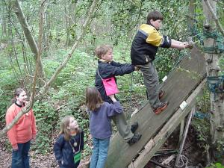

Learning about nature' is a broad objective and teachers daily confront the limitations of the classroom. If our aim is to teach and learn about nature in order to live in harmony with it, the farm can become a place with the explicit aim of helping individuals in the process of 'learning to live lightly' and do this in an integrated and sequential way. As such programs for school children at the farm will offer something not available elsewhere. A Permaculture for children learning experience could include the following:

* Increasing the understanding of basic ecological principles by making the 'abstract' more 'concrete' through kinaesthetic[11] activities
* Making it happen outside in a place where natural processes can be easily observed
* Emphasizing that we are part of the natural world
* Engaging the emotions, senses and intellect
* Including time for contemplation, community and creativity by focusing on developing comprehension of ecological principles as a precursor to a later understanding of frameworks such as Mollison and [Holmgren's[12] Design Principles](http://www.green-shopping.co.uk/books/ebooks/free-ebooks/essence-of-permaculture.html).

The Neu Family Farm will provide Permaculture education to school children by developing a relationship with the Collier Youth Services[13] and the director of the Kateri Environmental Program, Dan Smith. The Kateri environmental programs offer year-round educational and recreational activities for children and families. The program encourages a love of nature and a respect for the Environment. The Kateri programs cover a wide range of environmental topics while incorporating fun and adventure into every activity.

The Kateri job experience & training (JET) program is a life and job skills program designed to help at-risk students become more employable and develop into fully contributing members of the community. The target population includes students aged 13 to 21 who are in need of guidance and structure to prepare for a productive future. Classified and non-classified teens that need more intensive job readiness training can benefit from this program. JET participants can provide resources for cleaning up and helping to convert the Keyport Wellbeing farm and eco-center. Dan was formerly the Education Director at the Liberty Science Center and can provide advice as we develop the youth facet of the educational goal for the Neu Family Farm.

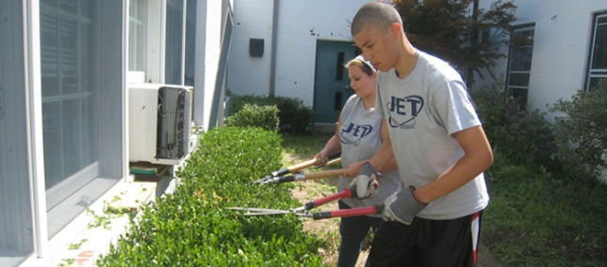

**Wellbeing Farm, a Place for Scholarship and Contemplation**

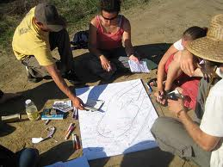

Education at the Neu Family Farm can incorporate classes and residencies for adults involved in Transition, Permaculture and cruelty free animal husbandry. These short and long term courses or residencies can become one tool that will enable people to learn and then teach how to work locally to transition our communities away from a fossil fuel-based economy to a “restorative economy,” an economy dedicated to core values of human and environmental health and safety, cultural and biological diversity, care for commonly held resources, and cooperative nonviolence. A restorative economy is human-scaled. It embraces alternative locally based energy, is less extractive and less violent.

Facilities could developed in which intimate conferences could be accommodated, and where Permaculture certification,[14] alternative energy, water conservation, organic and biodynamic farming, and “deep” Transition[15] classes can be taught. The attendees would be able to avail themselves to the ongoing Permaculture, alternative energy, hunter-gatherer skills, natural building, and water conservation projects taking place at the Farm in a “hands-on” way.

Most importantly Wellbeing farm can provide a quiet, bucolic, and beautiful landscape in which to think and write – to experience the relationship between humans, animals, and the natural world, and to learn how to take the experience away with them.

Instructors and mentors can be drawn from a variety of disciplines and experiences. The farmer or farm family chosen to manage the Farm must have a unique set of qualifications to enable him/her to oversee, not just the day to day operations of the Farm, but to direct the education program as well.

1. the state of being happy, healthy, or prosperous
2. <http://en.wikipedia.org/wiki/Tellus_Institute>
3. <http://en.wikipedia.org/wiki/Stockholm_Environment_Institute>
4. <http://www.gtinitiative.org/documents/Great_Transitions.pdf>
5. <http://transitionus.org/>
6. Aquaponics  is a sustainable [food production](http://en.wikipedia.org/wiki/Agriculture) system that combines a traditional [aquaculture](http://en.wikipedia.org/wiki/Aquaculture) (raising [aquatic animals](http://en.wikipedia.org/wiki/Aquatic_animal) such as snails, [fish](http://en.wikipedia.org/wiki/Fish), [crayfish](http://en.wikipedia.org/wiki/Crayfish) or [prawns](http://en.wikipedia.org/wiki/Prawn) in tanks) with [hydroponics](http://en.wikipedia.org/wiki/Hydroponics) (cultivating plants in water) in a [symbiotic](http://en.wikipedia.org/wiki/Symbiosis) environment. In aquaculture, [effluents](http://en.wikipedia.org/wiki/Effluent) accumulate in the water, increasing toxicity for the fish. This water is led to a hydroponic system where the[by-products](http://en.wikipedia.org/wiki/By-product) from the aquaculture are filtered out by the plants as vital nutrients, after which the cleansed water is recirculated back to the animals. The term *aquaponics* is a [combination](http://en.wikipedia.org/wiki/Portmanteau) of the terms *aquaculture* and *hydroponic*.
7. <http://www.animalwelfareapproved.org/>
8. <http://www.certifiedhumane.org/>
9. <http://www.americangrassfed.org/>
10. <http://foodalliance.org/>
11. Kinesthetic learning (also known as tactile learning) is a [learning style](http://en.wikipedia.org/wiki/Learning_style) in which [learning](http://en.wikipedia.org/wiki/Learning) takes place by the student carrying out a physical activity, rather than listening to a lecture or watching a demonstration. People with a kinesthetic learning style are also commonly known as "do-ers".
12. Founders of Permaculture
13. <http://www.collierservices.com/>
14. In a world of diminishing resources and increasing stresses on natural and social systems we must rapidly implement strategies to**restore degraded landscapes, shelter and feed displaced and hungry people, and convert our energy-wasteful infrastructure to holistic and ecological systems that meet their own needs and the needs of those who manage them.** A Permaculture Certification course lays the foundation for understanding**the workings of natural systems and for designing human environments that produce food, shelter, and energy.** It also provides participants with models of community development and extension by which they can **create networks of support for themselves and empower others to do the same.**
15. <http://www.deeptransition.com/a-call-to-evolutionary-catalysts/>